Discipleship from the beginning  Because every story starts from the beginning! | A Discipleship program seeking God from the beginning in Genesis!  Gregory Bryant Wiles

Discipleship From The Beginning
biblegodsword.com
9/10/2025 4:36 PM

(If you will be part of a group study, before meeting you should read this introduction below, the first Lesson “Origins”, and Genesis 6:11-20 and 7:11-23.)

Introduction
This Discipleship course can save anyone, including the harshest skeptics – Atheists like me. My friend who led me to Christ had also been an Atheist, but became a born-again Christian through a similar path, by examining the EVIDENCE, and studying the Bible.
Discipleship Definition: “The process of training people incrementally in some discipline or way of life.” For our purposes, this means teaching people to become true followers of Jesus Christ, who then become capable of leading others to do the same.
[“Scripture quotations taken from the (NASB®) New American Standard Bible®, Copyright © 1960, 1971, 1977, 1995, 2020 by The Lockman Foundation. Used by permission. All rights reserved. lockman.org”]

The Call to Discipleship
Christian discipleship is the process of following and becoming increasingly like Jesus Christ. This transformative path is not a singular event but a continuous, lifelong endeavor of growth and spiritual development. It commences with a "born-again" experience, marking a spiritual rebirth, and extends through a sustained commitment to emulate Christ, leading to a profound transformation of one's life.
Why is this particular Discipleship series necessary?
- I searched for Discipleship materials that started with Evidence of God, and proof that the Bible is God’s Word, but could not find a single one. So I developed this course patterned after my own path of learning. Hundreds of people have found Christ through this method.
- Most churches offer little if any Discipleship education and training.
- Most books and online resources do not include evidence of the Bible’s Divine Inspiration.
- Most books and online resources do not teach that Genesis and the Creation, Sin, and Flood accounts are all TRUE EVENTS.
- Most existing resources are inadequate.
- I was amazed to find that there is a wide range of ideas of what discipleship involves. I believe the main purpose is to find “The Way” from the beginning (Genesis). Just like reading any story, you must start from the beginning or you won’t understand it. Also, we should try to duplicate ourselves by teaching others the foundational truths with tools to grow.
- Surveys prove that other Discipleship efforts have not been effective:
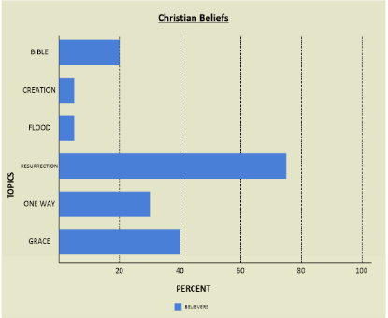
Most people don’t believe the Bible is God’s Word, Creation and the Flood were actual events, that Jesus is the ONLY WAY to salvation, or we are saved by Grace only!

This is mainly because Church leaders do not believe the Bible either!
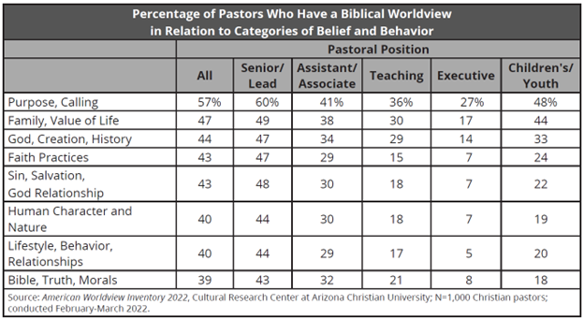
Also, a 2023 survey found that 70% of Christian youth who attended a secular college abandoned their faith within one year! They obviously lacked a firm Biblical foundation!
The Goals of This Discipleship Course
- Lead people to Christ (Don’t assume they are already saved!)
- Teach basic tools needed to properly study the Bible
- Allow and encourage the student to use these tools to further understand Scripture
- Guide the student to the foundational truths of the Bible
- Help to grow a strong belief and trust in God’s Word
- Equip the student to be a Disciple and train others if they so desire
The primary method in these lessons is to provide many scriptures, and let the reader discover their meaning. Minimal commentary will be given.
Romans 10:17 So faith comes from hearing, and hearing by the word of Christ.
Even as a child I knew that if there was a Creator, then Evolution was a lie and if Evolution was a fact, then there was no God. They are completely opposites. When I was an atheist, Christians called me stupid for not believing God.
But recently I discovered something amazing. For decades I've been frustrated that Christians wouldn't give financially or help me in my mission to expose the Evolution lie. In 2019, I decided to research recent polls to get an accurate idea of how many atheists need to be reached. I was shocked to find that today, 95% of people in the world believe Evolution! I thought I had been trying to reach a very small minority, but instead it's 95% of the world, including religious people who are believing the lie! Since 1973, it's still the religious people swearing at me and calling me stupid, but now because I don't believe Evolution anymore! Also, ALL of the major religions today say that Evolution is compatible with their beliefs! Now I know that's why nobody would support my Creation/Evolution mission.
The information provided in this Discipleship series is very similar to what led me to Christ. It has the power of God’s Word through the scriptures included, but also points to actual evidences found around the world supporting them.
Similar to the way I was saved from Atheism into Christianity, this program logically starts at THE BEGINNING and asks:
- Were we Created or did all life Evolve from nothing?
- If there is a Creator God, who is He?
- Is the Bible Gods’ Word and is it trustworthy?
- How should we study the Bible?
- What is the human condition?
- Who are God, Jesus, and the Holy Spirit?
- What do we know about Heaven, Hell and Satan?
- How do we get saved?
- How should we pray?
- What is the Church and what should it do?
- What is the future for Christians?

Lesson 1 Origins

In The Beginning
This Discipleship course is very rare. It is based on EVIDENCE FIRST! You don’t have to hope, or pray, or cross your fingers, or wonder if the Bible is true. You will KNOW that it is TRUE! Some people say you must throw your brain away and believe on faith! That’s nonsense. The Bible says to seek the truth, which is evidence. Sadly, it’s amazing that most people need NO evidence to believe a lie (Evolution), but DEMAND ENDLESS PROOF and still ignore the TRUTH (Creation)!
Romans 1:19 because that which is known about God is evident within them; for God made it evident to them. ²⁰ For since the creation of the world His invisible attributes, that is, His eternal power and divine nature, have been clearly perceived, being understood by what has been made, so that they are without excuse.
Acts 2:32 It is this Jesus whom God raised up, a fact to which we are all witnesses.
Jeremiah 10:10 But the Lord is the true God; He is the living God and the everlasting King. The earth quakes at His wrath, And the nations cannot endure His indignation.
In the beginning, there was a Creator who created all things in a short time, OR there is an Ongoing Interminable Process of Random Evolution resulting in everything.
The Creation story is given to us in the Bible in the book of Genesis. The Bible claims to be God’s Word. God is the Creator.
Evolution is a story that is still evolving today and has many different versions. The author of the Evolution lie is ultimately Satan.
These are opposite models. ALL EVIDENCE will support Creation, OR ALL EVIDENCE will support Evolution!
Most churches cannot lead people to Christ. The proof is in the following surveys:
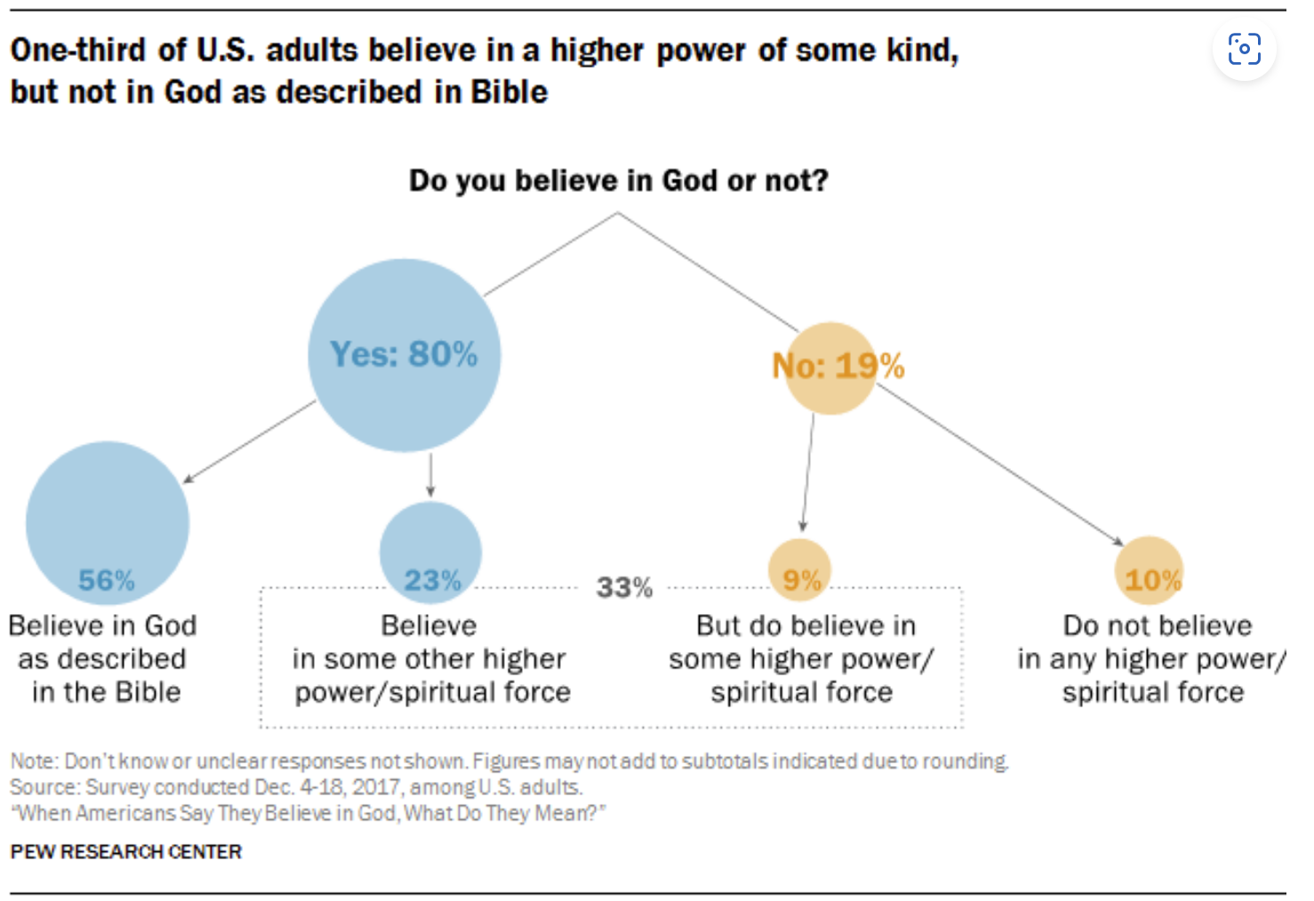
These statistics are based on the following research:
- 57% Pew Research Center, 2019
- 70% American Enterprise Institute, 2019
- 61% General Social Survey, 2018
- 66% Voter Survey Group, 2018

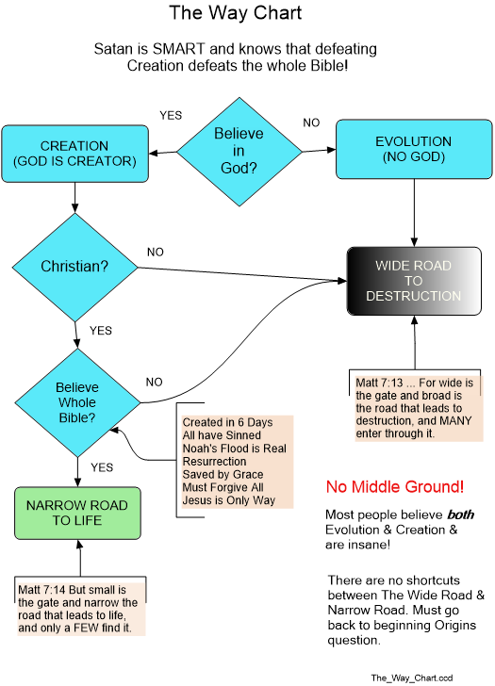
Matthew 7:8 For everyone who asks receives, and the one who seeks finds, and to the one who knocks it will be opened.
Hebrews 11:6 And without faith it is impossible to please Him, for the one who comes to God must believe that He exists, and that He proves to be One who rewards those who seek Him.
Seeking God, the Narrow Road to Life, and the Wide Road to Destruction are life long processes. Even when you think you are neutral or passive, time is passing by which will bring you to the destination YOU have chosen!
If you earnestly seek the truth, you will end up at Jesus!
If you earnestly study the evidence for evolution, you will reject it.
If you earnestly study the evidence for the Bible, you will believe it.
Sadly most people don't believe the evidence. But a smart person will change their view if new information contradicts their belief.

Creation/Flood – The Genesis Story
WHY DO WE DO THAT?
In the Garden of Eden, God told Adam and Eve not to eat from the tree of the knowledge of good and evil or they would die. Satan told Eve that she wouldn't die. So, Satan said God was lying. Without thinking, Eve ate from the tree and then so did Adam.
Why did they do that?
Today, God says He created all living things, male and female, in 6 days. Satan says, "no He didn't". All things Evolved from the beginning.
So how many millions of years was it between the first male and the first female?
Today over 95% of the world believes Evolution without giving it a thought.
Why do we do that?
Like I once did, people still say they believe Evolution "because scientists have proven it". But if Evolution is TRUE, why after billions of years, billions of people still can't say "because I have seen living things change into other living things"?
Yes, some scientists believe Evolution, but after hundreds of years, they still cannot prove it. Other scientists know that Evolution is impossible, In fact, God created all life in 6 days, and the whole earth was recently flooded!
But it doesn't matter what scientists or anybody else believes.
What does the evidence say? The overwhelming global evidence supports Creation and the Flood.
If you honestly want the truth, you can get on the internet today and search for “Evolution Creation Debate”. Then you can make an informed decision. Is God the liar, or is Satan?

Before this first group meeting, you should have studied these verses for discussion:
Genesis 1:1-31
What key messages are given in these verses from the Bible?
_______________________________________________________________________________________
_______________________________________________________________________________________
_______________________________________________________________________________________

Creation Evidence:

Biology
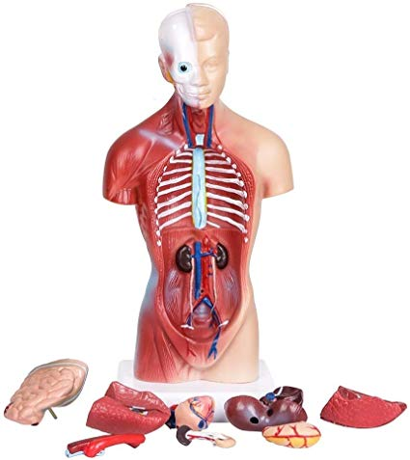
Psalm 139:13 For You created my innermost parts; You wove me in my mother’s womb. ¹⁴ I will give thanks to You, because I am awesomely and wonderfully made; Wonderful are Your works, And my soul knows it very well.
All life, male and female, reproduce faithfully after their kind just as God says:
Genesis 1:24 Then God said, “Let the earth produce living creatures according to their kind: livestock and crawling things and animals of the earth according to their kind”; and it was so.
Never has one kind of creature become a different kind of creature.
Also, the brains of all living things are the living “computer hardware”. Every living brain has been programmed with the “computer software” necessary to operate every function of each specific living thing! Software is “logic” which is essentially thoughts which cannot be seen or touched!
The populations of all living things indicate a recent history of just thousands of years.
If you need more help believing that we were Created, see the Resource list at the end.

The Global Flood - The Genesis Story
Before this first group meeting, you should have studied these verses for discussion:
Genesis 6:11-20 and 7:11-23
The Global Flood is discussed here because the majority of people deny it along with Creation. But Jesus believes it:
Matthew 24:38 For as in those days before the flood they were eating and drinking, marrying and giving in marriage, until the day that Noah entered the ark,
The Global Flood of the Bible is not just a parable or symbolism of a moral story. Parables and fictional stories do not contain specific details like person’s names, locations, dates, or construction measurements.

Flood Evidence:
If there was a Global Flood, that would leave a mark!
Consider that both Creation and Evolution acknowledge that all land was under water at some time. But was it a little water and a lot of time, or a lot of water and a little time?
There is Global physical evidence of a Global Flood!
There are over 500 Global Flood stories written and verbal, from every continent, and in nearly every language.
Even in their journals, the scientific community reports thousands of floods throughout history and geology, but claim they were all local flash floods!
Rock layers show rapid deposition by water. Layers were deposited thousands of feet deep and only then were they fractured by faults, eroded by rivers, and pierced by volcanoes!
The Fossils and rock layers all point to evidence of a young earth. If Evolution is an ongoing process, millions of dead things would be in the process of fossilization. Instead, no where in the world are any living things being fossilized as they were in the Global Flood!

For more information on the Global Flood, see the Resource list.

Evolution
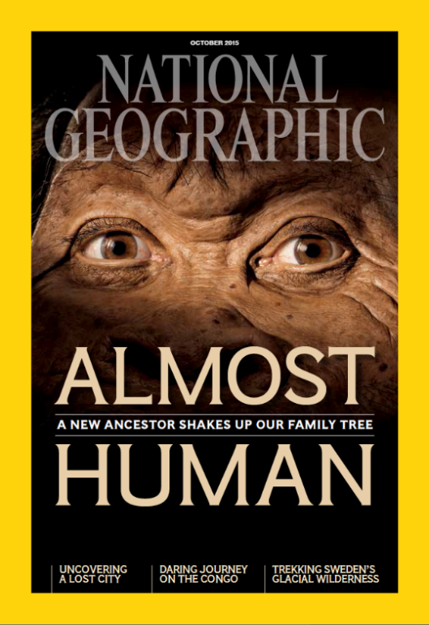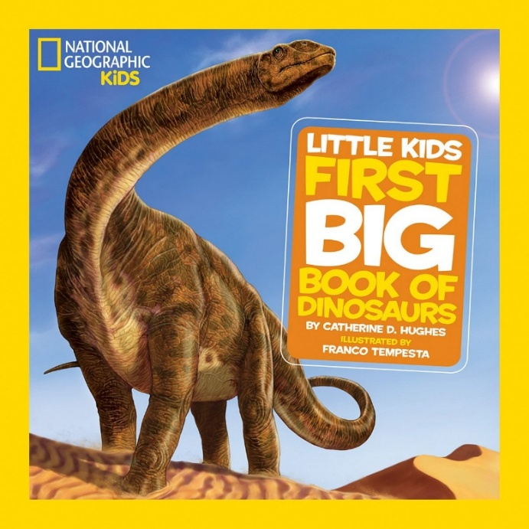
As mentioned earlier, over 95% of the world believes Evolution. But in the fossils and among the living, no one has ever witnessed one living kind of creature evolving into another living kind of creature!
Verses:
2 Peter 3:3 Know this first of all, that in the last days mockers will come with their mocking, following after their own lusts, 4 and saying, “Where is the promise of His coming? For ever since the fathers fell asleep, all things continue just as they were from the beginning of creation.” 5 For when they maintain this, it escapes their notice that by the word of God the heavens existed long ago and the earth was formed out of water and by water, 6 through which the world at that time was destroyed by being flooded with water. 7 But by His word the present heavens and earth are being reserved for fire, kept for the day of judgment and destruction of ungodly people.

This is both a prophecy and a warning about the Evolution lie, yet even today it is rarely recognized as either!
Colossians 2:8 See to it that there is no one who takes you captive through philosophy and empty deception in accordance with human tradition, in accordance with the elementary principles of the world, rather than in accordance with Christ.

NO Evidence for Evolution!:
"Prehistoric" means "describing the period before there were written records". What it really means is that there is no God, the Bible is a lie, Evolution is a fact!
Consider that both Creation and Evolution acknowledge that all land was under water at one time. But was it a little water and a lot of time, or a lot of water and a little time?
No one hates the one true God. They make up their own version of a god and hate that! Their version of a god is not based on evidence, but their own feelings and what other people say or do in the name of their own religions.
ALL claimed evidence for Evolution is MISSING!
- Time – missing billions of years
- Biology – missing trillions of transitional forms
- Geology – missing thousands of feet of rock layers and billions of fossils
Biology – Creatures always reproduce “after their kind”. No living thing has ever changed into another living thing!
Fossils – Always appear fully formed without transitions, live for generations, then go extinct or still exist today with only minor changes.
Radiometric Dating:
When scientists need to know the age of a fossil, they send a sample to a lab.
These labs use Radiometric dating methods, which involve at least a dozen FALSE ASSUMPTIONS! Since they’re paid for this service, they are under great financial pressure, to give the date that scientists want!
In fact, the first question on their receiving form is, "How old do you think it is?"

These are only a few examples of Evidence about our origins. If you need to satisfy your doubts more, see the resources listed at the end of this program.

With the internet today, anybody can see media of all kinds to get their answers.

[Read Lesson 2 The Bible before the next group study]

Lesson 2 The Bible
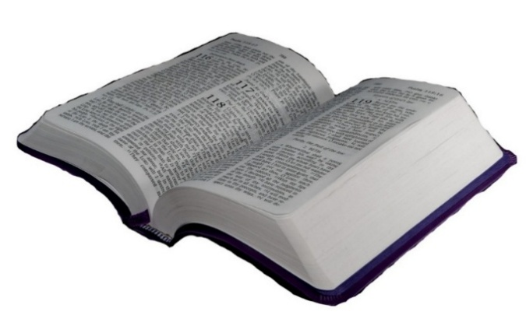
Before embarking on a deep study of the Bible, it’s important to ask “Why should I believe the Bible?” We all should be seeking to find evidence that it is truth and not fiction.

The Bible has a unique history, authorship, and construction:
- The Bible is a collection of 66 books. There are 39 books in the Old Testament, and 27 books in the New Testament.
- The Bible was written by more than 40 people in three languages over a time period of approximately 1,600 years.
- The Bible is accurate in all matters of history, science, and in every issue of life.
- It contains hundreds of prophecies, many written thousands of years before the event was fulfilled. Often the human author does not understand what he was asked to report.
- The Bible does not contradict itself. (Some contradictions are claimed. Do your own research if you feel the need.)
- The Bible fits together perfectly, as if one man wrote it, because the Holy Spirit is the author of all 66 books.
- The Bible has survived numerous attempts to destroy it from the beginning.
- It has been the highest selling book for centuries.
- No other book has had more books written about it!

What the Bible claims about itself
It claims to be God’s Word – His revelation to mankind. The whole Bible is His revelation to us, not just the book of Revelation within the Bible.
It is inspired by God- 2 Timothy 3:16 All Scripture is inspired by God and beneficial for teaching, for rebuke, for correction, for training in righteousness; ¹⁷ so that the man or woman of God may be fully capable, equipped for every good work.
It is inerrant - Proverbs 30:5 Every word of God is pure; He is a shield to those who take refuge in Him. ⁶ Do not add to His words Or He will rebuke you, and you will be proved a liar.
It is infallible – Joshua 21:45 Not one of the good promises which the Lord had made to the house of Israel failed; everything came to pass.
It is authoritative – also 2 Timothy 3:16
It is true - Psalm 119:160 The sum of Your word is truth, And every one of Your righteous judgments is everlasting.
It’s all about Jesus - John 5:39 You examine the Scriptures because you think that in them you have eternal life; and it is those very Scriptures that testify about Me;
The Bible tells us things about God that we could not know just by studying His creation.
People defending the Bible often say “the Bible is not a book of Science or History”. Anybody saying such things fears that the Bible does not agree with “Science” and they cannot defend the Bible. You will learn through this study that the Bible is accurate in history and all the sciences whenever it speaks on those topics! Anytime you doubt something the Bible says, you need to research it without fear because you will indeed find it true!
Old Testament Scriptures that Jesus endorsed as True:
Creation (Matthew 19:4-5, Mark 13:19).
The personality and character of Satan (John 8:44).
The universal flood (Luke 17:26-27).
Destruction of Sodom and Gamorrah (Luke 17:28-30).
Moses and the burning bush (Mark 12:26).
Manna in the wilderness (John 6:32).
Jonah swallowed by a big fish (Matthew 12:39-40).
The existence of the tabernacle (Luke 6:3-4).

Important - The Bible is what defines Christianity, not the false teaching or actions of certain people.
Notes:
_________________________________________________________________________________
_________________________________________________________________________________
_________________________________________________________________________________
Optional Research about the Bible:
Canonicity of the Bible – who decided the 66 books of the Bible are Scripture and why?
• Prophetic Authorship
• Witness of the Spirit
• Acceptance
• The Promise of Jesus
o As far as the New Testament is concerned, we have the promise of Jesus.
o But the Helper, the Holy Spirit, whom the Father will send in My name, He will teach you all things, and bring to your remembrance all things that I said to you (John 14:26).
• Nature of God
o Another reason we can be assured the correct books in the Bible is the nature of God. It has been estimated there are a quintillion stars in the universe and the Bible says God calls them by their names. If God is able to do this, He certainly is able to preserve intact His Word for the benefit of mankind.

Hermeneutics
Interpretation Defined: an explanation of the meaning of another's artistic or creative work; an elucidation. Trying to determine what an author meant in their writings.
Hermeneutics definition: The science of interpretation and explanation; exegesis; esp., that branch of theology which defines the laws whereby the meaning of the Scriptures is to be ascertained.
The Bible is God’s Word – His Revelation to humankind. As such, we need to take extraordinary measures to understand it correctly.

I know what it SAYS, but what does it MEAN?
- General Principles of Interpretation
- Assume the Bible is authoritative (because it is) 2 Timothy 3:16 All Scripture is inspired by God and beneficial for teaching, for rebuke, for correction, for training in righteousness; ¹⁷ so that the man or woman of God may be fully capable, equipped for every good work.
- NO Interpretation is the BEST Interpretation. Think carefully about trying to make scripture say something other than the obvious. (ie. Six days of Creation are literal 24 hour days, not millions of years.)
- Scripture best interprets Scripture. First see what other scriptures say about the same subject matter. Some studies show that the Bible refers to itself over 60,000 times!
- Purpose is to determine the author’s (and God’s) meaning, not some other agenda.
- Holy Spirit is necessary to understand & interpret Scripture. John 16:13 But when He, the Spirit of truth, comes, He will guide you into all the truth; for He will not speak on His own, but whatever He hears, He will speak; and He will disclose to you what is to come.
- Consider the intended audience of the Scripture.
- Interpret Experience in light of Scripture, not vice-versa.
- Purpose of Bible is personal “Change”, NOT “Knowledge”. 2 Timothy 3:16
- Each person has the Right/Responsibility to be in the Word himself.
- God’s Promises throughout the Bible are available to each of us today!
- Grammatical Principles of Interpretation
- Scripture has only ONE MEANING, should be taken literally.
- Interpret Words in Harmony with Author and his Times.
- Interpret a Word in Relation to its Sentence and Context.
- Interpret a Passage in Harmony with its Context.
- Inanimate Object for Living Being may be considered Figurative.
- Expression out of character with thing consider it Figurative.
- Parable – Consider only principal parts for conclusions. Real events include names, locations, time references. Parables and fictional stories DO NOT include details like names, locations, dates, or measurements, etc.
- Prophets take literally – with few exceptions – may be installments.
- Historical Principles of Interpretation
- Interpret in light of Historical Context.
- Although Revelation is Progressive, Bible is still a Unit.
- Historical Events are symbols ONLY if Scripture says so.
There are many books written about Hermeneutics, but we must do everything possible to AVOID INTERPRETATING the Bible at all! First, try to abide by these two rules mentioned above:
- NO Interpretation is the BEST Interpretation. Think carefully about trying to make scripture say something other than the obvious. (ie. Six days of Creation are literal 24 hour days, not millions of years.)
- Scripture best interprets Scripture. First see what other scriptures say about the same subject matter. Some studies show that the Bible refers to itself thousands of times!
What are the top 3 rules of Hermeneutics (Interpreting the Bible)?
_______________________________________________________________________________
_______________________________________________________________________________
_______________________________________________________________________________
[Read Lesson 3 Creation And Fall of Man before the next group study]

Lesson 3 Creation And Fall of Man
Genesis 1:26 Then God said, “Let Us make mankind in Our image, according to Our likeness; and let them rule over the fish of the sea and over the birds of the sky and over the livestock and over all the earth, and over every crawling thing that crawls on the earth.”
Adam and Eve were made in God’s image. All of God’s original Creation was very GOOD! God walked with Adam and Eve in the Garden of Eden.

Sin (The Fall)
Sin as defined by the Bible is any transgression of the law of God. Basically, any disobedience to God, or even declaring our independence from God are sins.
Origin of Sin
Genesis 2:17 but from the tree of the knowledge of good and evil you shall not eat, for on the day that you eat from it you will certainly die.”
Genesis 3:1 Now the serpent was more cunning than any animal of the field which the Lord God had made. And he said to the woman, “Has God really said, ‘You shall not eat from any tree of the garden’?” ² The woman said to the serpent, “From the fruit of the trees of the garden we may eat; ³ but from the fruit of the tree which is in the middle of the garden, God has said, ‘You shall not eat from it or touch it, or you will die.’” ⁴ The serpent said to the woman, “You certainly will not die! ⁵ For God knows that on the day you eat from it your eyes will be opened, and you will become like God, knowing good and evil.” ⁶ When the woman saw that the tree was good for food, and that it was a delight to the eyes, and that the tree was desirable to make one wise, she took some of its fruit and ate; and she also gave some to her husband with her, and he ate. ⁷ Then the eyes of both of them were opened, and they knew that they were naked; and they sewed fig leaves together and made themselves waist coverings.
Eve’s Disastrous Decisions:
- She should never have even gone to the tree. Other allowed food was abundant.
- Eve was by herself at the tree when Satan approached her.
- After Satan’s Lie, Eve had the choice to believe God or Satan.
- Eve had no evidence about the tree. She just chose what she wanted to believe.
- Eve’s choice was to Believe God or Satan!
- Eve did not Consult with Adam.
- Eve did not Consult with God.
Adam and Eve’s Decision:
Genesis 3:6…she took some of its fruit and ate; and she also gave some to her husband, and he ate
Through believing Satan instead of God, they disobeyed God’s authority and desired to be like God themselves:
Genesis 3:5 For God knows that on the day you eat from it your eyes will be opened, and you will become like God, knowing good and evil.
This is the same sin that caused Satan himself to fall:
Isaiah 14:14 I will ascend above the heights of the clouds; I will make myself like the Most High.’
Adam and Eve’s Excuses:
Genesis 3:12 The man said, “The woman whom You gave to be with me, she gave me some of the fruit of the tree, and I ate.” 13 Then the Lord God said to the woman, “What is this that you have done?” And the woman said, “The serpent deceived me, and I ate.”
Adam blamed Eve and ultimately God for creating her! But we also have no excuse because we are responsible for what we Believe!
The Consequences of Sin:
Genesis 3:14 Then the Lord God said to the serpent,
“Because you have done this, Cursed are you more than all the livestock,
And more than any animal of the field; On your belly you shall go,
And dust you shall eat All the days of your life;
15 And I will make enemies Of you and the woman, And of your offspring and her Descendant; He shall bruise you on the head, And you shall bruise Him on the heel.” 16 To the woman He said, “I will greatly multiply Your pain in childbirth,
In pain you shall deliver children; Yet your desire will be for your husband, And he shall rule over you.” 17 Then to Adam He said, “Because you have listened to the voice of your wife, and have eaten from the tree about which I commanded you, saying, ‘You shall not eat from it’; Cursed is the ground because of you;
With hard labor you shall eat from it All the days of your life.
18 Both thorns and thistles it shall grow for you; Yet you shall eat the plants of the field; 19 By the sweat of your face You shall eat bread,
Until you return to the ground, Because from it you were taken;
For you are dust, And to dust you shall return.”

Death- God said “for on the day that you eat from it you will certainly die.”
List some things that began to die that day:
_______________________________________________________________________
_______________________________________________________________________
_______________________________________________________________________

The Global Flood
It’s important to note here that the Global Flood was an actual event and a major consequence of sin. The whole world was devastated. Most plants, animals, and humans died. You can review it in Genesis chapters 6 through 9.
All have sinned
Romans 6:23 For the wages of sin is death, but the gracious gift of God is eternal life in Christ Jesus our Lord.
Ephesians 2:1 And you were dead in your offenses and sins, 2 in which you previously walked according to the course of this world, according to the prince of the power of the air, of the spirit that is now working in the sons of disobedience. 3 Among them we too all previously lived in the lusts of our flesh, indulging the desires of the flesh and of the mind, and were by nature children of wrath, just as the rest.
Isaiah 59:2 But your wrongdoings have caused a separation between you and your God, And your sins have hidden His face from you so that He does not hear.
Romans 3:23 for all have sinned and fall short of the glory of God, ²⁴ being justified as a gift by His grace through the redemption which is in Christ Jesus,
James 2:10 For whoever keeps the whole Law, yet stumbles in one point, has become guilty of all.

[Read Lesson 4 God before the next group study]

Lesson 4 - God

He is the Creator of all things

Genesis 1:1 In the beginning God created the heavens and the earth.

Jeremiah 51: It is He who made the earth by His power, Who established the world by His wisdom, And by His understanding He stretched out the heavens.

Isaiah 44:24 This is what the Lord says, He who is your Redeemer, and the One who formed you from the womb: “I, the Lord, am the Maker of all things,
Stretching out the heavens by Myself And spreading out the earth alone,

There is only ONE God
Isaiah 45:21 Declare and present your case; Indeed, let them consult together.
Who has announced this long ago? Who has long since declared it? Is it not I, the Lord? And there is no other God besides Me, A righteous God and a Savior; There is none except Me. ²² Turn to Me and be saved, all the ends of the earth; For I am God, and there is no other.
John 17:3 And this is eternal life, that they may know You, the only true God, and Jesus Christ whom You have sent.

The Trinity
The God is the Father.
Philippians 1:2 Grace to you and peace from God our Father and the Lord Jesus Christ.
Jesus is God.
Titus 2:13 looking for the blessed hope and the appearing of the glory of our great God and Savior, Christ Jesus,
John 10:30 I and the Father are one.” 31 The Jews picked up stones again to stone Him. 32 Jesus replied to them, “I showed you many good works from the Father; for which of them are you stoning Me?” 33 The Jews answered Him, “We are not stoning You for a good work, but for blasphemy; and because You, being a man, make Yourself out to be God.”
The Holy Spirit is God.
Acts 5:3-4 But Peter said, “Ananias, why has Satan filled your heart to lie to the Holy Spirit and to keep back some of the proceeds of the land? 4 While it remained unsold, did it not remain your own? And after it was sold, was it not under your control? Why is it that you have conceived this deed in your heart? You have not lied to men, but to God.”
Acts 2:24 But God raised Him from the dead, putting an end to the agony of death, since it was impossible for Him to be held in its power.
John 10:18 No one has taken it away from Me, but I lay it down on My own. I have authority to lay it down, and I have authority to take it back. This commandment I received from My Father.”
John 2:19 Jesus answered them, “Destroy this temple, and in three days I will raise it up.” 20 The Jews then said, “It took forty-six years to build this temple, and yet You will raise it up in three days?” 21 But He was speaking about the temple of His body. 22 So when He was raised from the dead, His disciples remembered that He said this; and they believed the Scripture and the word which Jesus had spoken.
1 Peter 3:18 For Christ also suffered for sins once for all time, the just for the unjust, so that He might bring us to God, having been put to death in the flesh, but made alive in the spirit;
Acts 10:38 You know of Jesus of Nazareth, how God anointed Him with the Holy Spirit and with power, and how He went about doing good and healing all who were oppressed by the devil, for God was with Him.
Romans 8:11 But if the Spirit of Him who raised Jesus from the dead dwells in you, He who raised Christ Jesus from the dead will also give life to your mortal bodies through His Spirit who dwells in you.
Other traits of God:
1 John 3:20 that if our heart condemns us, that God is greater than our heart, and He knows all things.
Psalm 115:3 But our God is in the heavens; He does whatever He pleases.
Revelation 19:6 Then I heard something like the voice of a great multitude and like the sound of many waters, and like the sound of mighty peals of thunder, saying,
“Hallelujah! For the Lord our God, the Almighty, reigns.”
Jeremiah 23:23-24 “Am I a God who is near,” declares the Lord, “And not a God far off? ²⁴ Can a person hide himself in hiding places So that I do not see him?” declares the Lord. “Do I not fill the heavens and the earth?” declares the Lord.
Psalm 139:7 Where can I go from Your Spirit? Or where can I flee from Your presence? ⁸ If I ascend to heaven, You are there; If I make my bed in Sheol, behold, You are there.
1 Timothy 6:15 which He will bring about at the proper time—He who is the blessed and only Sovereign, the King of kings and Lord of lords,
1 Peter 1:15 but like the Holy One who called you, be holy yourselves also in all your behavior;
Jeremiah 12:1 Righteous are You, Lord, when I plead my case with You; Nevertheless I would discuss matters of justice with You: Why has the way of the wicked prospered? Why are all those who deal in treachery at ease?
1 John 4:8 The one who does not love does not know God, because God is love.
Psalm 90:2 Before the mountains were born Or You gave birth to the earth and the world, Even from everlasting to everlasting, You are God.
James 1:17 Every good thing given and every perfect gift is from above, coming down from the Father of lights, with whom there is no variation or shifting shadow.
The Triune God: One Essence, Three Persons
Concept | Explanation | Key Biblical Passages
One God | There is only one divine being, the singular Creator and Sustainer of all things. | Deuteronomy 6:4, Isaiah 45:21-22 ¹⁶
Three Persons | God eternally exists as Father, Son, and Holy Spirit. | Matthew 28:19 ¹⁶
Distinctness | The Father is not the Son, the Son is not the Holy Spirit, and the Holy Spirit is not the Father. | John 14:26, Acts 2:33 ¹⁶
Equality | Each Person is fully God, co-equal and co-eternal, possessing all divine attributes. | Titus 2:13, Acts 5:3-4 ¹⁶
Shared Attributes | Attributes like omnipotence, omniscience, holiness, and love are fully present in each Person. | Philippians 1:2, 2 Corinthians 3:17 ¹⁶
Unified Work | All three Persons are involved in every divine action (e.g., creation, redemption, judgment). | Genesis 1:1-2, John 5:19, 1 Corinthians 12:4-6 ¹⁷

In summary, the Trinity is not belief in three gods. There is only one God as scripture makes clear. This one God exists as three Persons.The three Persons are not each part of God, but are each fully God and equally God. There have always been and always will be three distinct persons in the Godhead. God is one in essence, three in Person.

Jesus
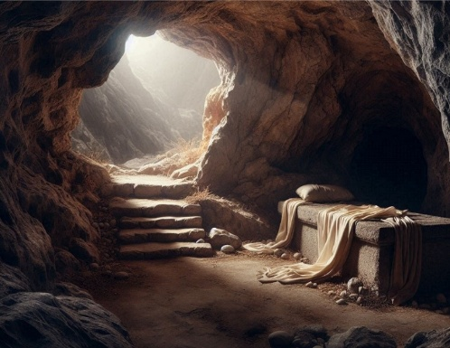
In the Old Testament
Isaiah 9:6 For a Child will be born to us, a Son will be given to us; And the government will rest on His shoulders; And His name will be called Wonderful Counselor, Mighty God,
Eternal Father, Prince of Peace. 7 There will be no end to the increase of His government or of peace On the throne of David and over his kingdom, To establish it and to uphold it with justice and righteousness From then on and forevermore. The zeal of the Lord of armies will accomplish this.
Micah 5:2 But as for you, Bethlehem Ephrathah, Too little to be among the clans of Judah, From you One will come forth for Me to be ruler in Israel. His times of coming forth are from long ago, From the days of eternity.”
Isaiah 53:5 But He was pierced for our offenses, He was crushed for our wrongdoings; The punishment for our well-being was laid upon Him, And by His wounds we are healed.
Psalm 22:16 For dogs have surrounded me; A band of evildoers has encompassed me; They pierced my hands and my feet. 17 I can count all my bones. They look, they stare at me; 18 They divide my garments among them, And they cast lots for my clothing.
In the New Testament
Hebrews 1:1 God, after He spoke long ago to the fathers in the prophets in many portions and in many ways, ² in these last days has spoken to us in His Son, whom He appointed heir of all things, through whom He also made the world.
1 Corinthians 8:6 yet for us there is only one God, the Father, from whom are all things, and we exist for Him; and one Lord, Jesus Christ, by whom are all things, and we exist through Him.
1 Corinthians 15:3-4 For I handed down to you as of first importance what I also received, that Christ died for our sins according to the Scriptures, ⁴ and that He was buried, and that He was raised on the third day according to the Scriptures,
2 Corinthians 5:21 He made Him who knew no sin to be sin in our behalf, so that we might become the righteousness of God in Him.
John 3:16 “For God so loved the world, that He gave His only Son, so that everyone who believes in Him will not perish, but have eternal life.
Romans 5:18 So then, as through one offense the result was condemnation to all mankind, so also through one act of righteousness the result was justification of life to all mankind.
John 14:9 Jesus *said to him, “Have I been with you for so long a time, and yet you have not come to know Me, Philip? The one who has seen Me has seen the Father; how can you say, ‘Show us the Father’?
Hebrews 4:15 For we do not have a high priest who cannot sympathize with our weaknesses, but One who has been tempted in all things just as we are, yet without sin.
John 1:1 In the beginning was the Word, and the Word was with God, and the Word was God.
Colossians 1:16 for by Him all things were created, both in the heavens and on earth, visible and invisible, whether thrones, or dominions, or rulers, or authorities—all things have been created through Him and for Him.

Holy Spirit
John 14:26 But the Helper, the Holy Spirit whom the Father will send in My name, He will teach you all things, and remind you of all that I said to you.
Acts 5:3 But Peter said, “Ananias, why has Satan filled your heart to lie to the Holy Spirit and to keep back some of the proceeds of the land? ⁴ While it remained unsold, did it not remain your own? And after it was sold, was it not under your control? Why is it that you have conceived this deed in your heart? You have not lied to men, but to God.”
Ephesians 4:30 Do not grieve the Holy Spirit of God, by whom you were sealed for the day of redemption.
1 Corinthians 2:10 For to us God revealed them through the Spirit; for the Spirit searches all things, even the depths of God. ¹¹ For who among people knows the thoughts of a person except the spirit of the person that is in him? So also the thoughts of God no one knows, except the Spirit of God. ¹² Now we have not received the spirit of the world, but the Spirit who is from God, so that we may know the things freely given to us by God.
Romans 5:5 and hope does not disappoint, because the love of God has been poured out within our hearts through the Holy Spirit who was given to us.
John 3:5-8 Jesus answered, “Truly, truly, I say to you, unless someone is born of water and the Spirit, he cannot enter the kingdom of God. ⁶ That which has been born of the flesh is flesh, and that which has been born of the Spirit is spirit. ⁷ Do not be amazed that I said to you, ‘You must be born again.’ ⁸ The wind blows where it wishes, and you hear the sound of it, but you do not know where it is coming from and where it is going; so is everyone who has been born of the Spirit.”
Galatians 3:1 You foolish Galatians, who has bewitched you, before whose eyes Jesus Christ was publicly portrayed as crucified? ² This is the only thing I want to find out from you: did you receive the Spirit by works of the Law, or by hearing with faith? ³ Are you so foolish? Having begun by the Spirit, are you now being perfected by the flesh?
Galatians 5:16 But I say, walk by the Spirit, and you will not carry out the desire of the flesh. ¹⁷ For the desire of the flesh is against the Spirit, and the Spirit against the flesh; for these are in opposition to one another, in order to keep you from doing whatever you want. ¹⁸ But if you are led by the Spirit, you are not under the Law.
Acts 1:8 but you will receive power when the Holy Spirit has come upon you; and you shall be My witnesses both in Jerusalem and in all Judea, and Samaria, and as far as the remotest part of the earth.”
1 Corinthians 12:7 But to each one is given the manifestation of the Spirit for the common good. ⁸ For to one is given the word of wisdom through the Spirit, and to another the word of knowledge according to the same Spirit; ⁹ to another faith by the same Spirit, and to another gifts of healing by the one Spirit, ¹⁰ and to another the effecting of miracles, and to another prophecy, and to another the distinguishing of spirits, to another various kinds of tongues, and to another the interpretation of tongues. ¹¹ But one and the same Spirit works all these things, distributing to each one individually just as He wills.
Galatians 5:22-23 But the fruit of the Spirit is love, joy, peace, patience, kindness, goodness, faithfulness, ²³ gentleness, self-control; against such things there is no law.
Titus 3:5 He saved us, not on the basis of deeds which we did in righteousness, but in accordance with His mercy, by the washing of regeneration and renewing by the Holy Spirit,
1 Corinthians 12:4-11 Now there are varieties of gifts, but the same Spirit. ⁵ And there are varieties of ministries, and the same Lord. ⁶ There are varieties of effects, but the same God who works all things in all persons. ⁷ But to each one is given the manifestation of the Spirit for the common good. ⁸ For to one is given the word of wisdom through the Spirit, and to another the word of knowledge according to the same Spirit; ⁹ to another faith by the same Spirit, and to another gifts of healing by the one Spirit, ¹⁰ and to another the effecting of miracles, and to another prophecy, and to another the distinguishing of spirits, to another various kinds of tongues, and to another the interpretation of tongues. ¹¹ But one and the same Spirit works all these things, distributing to each one individually just as He wills.
[Read Lesson 5 Heaven and Hell before the next group study]

Lesson 5 Heaven and Hell

HEAVEN
Matthew 7:21 “Not everyone who says to me, ‘Lord, Lord,’ will enter the kingdom of heaven, but only the one who does the will of my Father who is in heaven.
Matthew 21:25 John’s baptism—where did it come from? Was it from heaven, or of human origin?” They discussed it among themselves and said, “If we say, ‘From heaven,’ he will ask, ‘Then why didn’t you believe him?’
Matthew 24:30 “Then will appear the sign of the Son of Man in heaven. And then all the peoples of the earthwill mourn when they see the Son of Man coming on the clouds of heaven, with power and great glory.
Acts 1:11 “Men of Galilee,” they said, “why do you stand here looking into the sky? This same Jesus, who has been taken from you into heaven, will come back in the same way you have seen him go into heaven.”
Luke 22:43 An angel from heaven appeared to him and strengthened him.
Psalms 33:13 From heaven the LORD looks down and sees all mankind;
Mark 13:31 Heaven and earth will pass away, but my words will never pass away.
Philippians 3:20 But our citizenship is in heaven. And we eagerly await a Savior from there, the Lord Jesus Christ,

HELL
Mark 9:43 If your hand causes you to stumble, cut it off. It is better for you to enter life maimed than with two hands to go into hell, where the fire never goes out.
Matthew 18:9 And if your eye causes you to stumble, gouge it out and throw it away. It is better for you to enter life with one eye than to have two eyes and be thrown into the fire of hell.
Luke 16:23 In Hades, where he was in torment, he looked up and saw Abraham far away, with Lazarus by his side.
Revelation 1:18 I am the Living One; I was dead, and now look, I am alive for ever and ever! And I hold the keys of death and Hades.
Revelation 20:15 Anyone whose name was not found written in the book of life was thrown into the lake of fire.
People argue or hope that a loving God wouldn’t send “good” people to Hell.
- If you’ve understood the scriptures about Sin then you know that there are no “good people”.
  - Romans 3:23 for all have sinned and fall short of the glory of God, ²⁴ being justified as a gift by His grace through the redemption which is in Christ Jesus,
- We go to Heaven or Hell by our own CHOICE!
  - John 3:16 “For God so loved the world, that He gave His only Son, so that everyone who believes in Him will not perish, but have eternal life.
  - Matthew 7:13 “Enter through the narrow gate; for the gate is wide and the way is broad that leads to destruction, and there are many who enter through it. 14 For the gate is narrow and the way is constricted that leads to life, and there are few who find it.
The Battle for Your Mind will determine if you go to Heaven or to Hell.
God loves you, and wants you with Him in Heaven forever!
Satan hates God and wants to be like God himself. He hates you and wants you to spend eternity in Hell with him!
This is YOUR CHOICE! You are responsible for your choice. Just like Adam and Eve, you cannot blame anybody else, or any circumstance!

Satan
(We’ll discuss Satan here with the topic of Hell.)
Mark 4:15 These are the ones who are beside the road where the word is sown; and when they hear, immediately Satan comes and takes away the word which has been sown in them.
Acts 5:3 But Peter said, “Ananias, why has Satan filled your heart to lie to the Holy Spirit and to keep back some of the proceeds of the land?
Acts 26:17-19 rescuing you from the Jewish people and from the Gentiles, to whom I am sending you, ¹⁸ to open their eyes so that they may turn from darkness to light, and from the power of Satan to God, that they may receive forgiveness of sins and an inheritance among those who have been sanctified by faith in Me.’
Romans 16:19-21 For the report of your obedience has reached everyone; therefore I am rejoicing over you, but I want you to be wise in what is good, and innocent in what is evil. ²⁰ The God of peace will soon crush Satan under your feet.
1 Corinthians 7:5 Stop depriving one another, except by agreement for a time so that you may devote yourselves to prayer, and come together again so that Satan will not tempt you because of your lack of self-control.
2 Corinthians 11:13-15 For such men are false apostles, deceitful workers, disguising themselves as apostles of Christ. ¹⁴ No wonder, for even Satan disguises himself as an angel of light. ¹⁵ Therefore it is not surprising if his servants also disguise themselves as servants of righteousness, whose end will be according to their deeds.
1 Thessalonians 2:18 For we wanted to come to you—I, Paul, more than once—and Satan hindered us.
DEVIL:
Matthew 13:38-40 and the field is the world; and as for the good seed, these are the sons of the kingdom; and the weeds are the sons of the evil one; ³⁹ and the enemy who sowed them is the devil, and the harvest is the end of the age; and the reapers are angels. ⁴⁰ So just as the weeds are gathered up and burned with fire, so shall it be at the end of the age.
John 8:44 You are of your father the devil, and you want to do the desires of your father. He was a murderer from the beginning, and does not stand in the truth because there is no truth in him. Whenever he tells a lie, he speaks from his own nature, because he is a liar and the father of lies.
Acts 10:38 You know of Jesus of Nazareth, how God anointed Him with the Holy Spirit and with power, and how He went about doing good and healing all who were oppressed by the devil, for God was with Him
Acts 13:10 and said, “You who are full of all deceit and fraud, you son of the devil, you enemy of all righteousness, will you not stop making crooked the straight ways of the Lord?
Ephesians 4:27 and do not give the devil an opportunity.
Ephesians 6:11 Put on the full armor of God, so that you will be able to stand firm against the schemes of the devil.
1 Timothy 3:7 And he must have a good reputation with those outside the church, so that he will not fall into disgrace and the snare of the devil.
Hebrews 2:14 Therefore, since the children share in flesh and blood, He Himself likewise also partook of the same, so that through death He might destroy the one who has the power of death, that is, the devil,
James 4:7 Submit therefore to God. But resist the devil, and he will flee from you.
1 Peter 5:8 Be of sober spirit, be on the alert. Your adversary, the devil, prowls around like a roaring lion, seeking someone to devour.
1 John 3:8 the one who practices sin is of the devil; for the devil has been sinning from the beginning. The Son of God appeared for this purpose, to destroy the works of the devil.
1 John 3:10 By this the children of God and the children of the devil are obvious: anyone who does not practice righteousness is not of God, nor the one who does not love his brother and sister.
Serpent:
Revelation 12:9 And the great dragon was thrown down, the serpent of old who is called the devil and Satan, who deceives the whole world; he was thrown down to the earth, and his angels were thrown down with him.
god of this world:
2 Corinthians 4:4 in whose case the god of this world has blinded the minds of the unbelieving so that they will not see the light of the gospel of the glory of Christ, who is the image of God.
The Thief:
John 10:10 The thief comes only to steal and kill and destroy; I came so that they would have life, and have it abundantly.
The Evil One:
1 John 5:19 We know that we are of God, and that the whole world lies in the power of the evil one.
Ruler of this world:
John 12:31 Now judgment is upon this world; now the ruler of this world will be cast out.
Prince of the power of the air:
Ephesians 2:2 in which you previously walked according to the course of this world, according to the prince of the power of the air, of the spirit that is now working in the sons of disobedience.
Accuser:
Revelation 12:10 Then I heard a loud voice in heaven, saying, “Now the salvation, and the power, and the kingdom of our God and the authority of His Christ have come, for the accuser of our brothers and sisters has been thrown down, the one who accuses them before our God day and night.
Tempter:
1 Thessalonians 3:5 For this reason, when I could no longer endure it, I also sent to find out about your faith, for fear that the tempter might have tempted you, and our labor would be for nothing.
Demon:
James 2:19 You believe that God is one. You do well; the demons also believe, and shudder.
Other names for Satan you may look up:
Day Star
Liar, Father of Lies
Murderer
Beelzebub
Belial
Enemy

Satan's plan against us
Ultimately, Satan wants people to worship him rather than God. He wants to be like God. He tempted Adam and Eve saying they could be like God.
His methods include:
Doubt: makes you question
- “Has God really said, ‘You shall not eat from any tree of the garden’?”
- Is the Bible really true?
- Are you really saved?
- Is Jesus really the ONLY WAY to Heaven?
Discouragement: makes you look at your problems rather than at God.
Diversion:
- Makes the wrong things seem attractive and “right”.
- Makes you think you are saved when you are not.
Defeat: makes you feel like a failure so that you don't even try.
Delay: makes you put off doing something so that it never gets done.
Lies: tells direct lies.
- To Eve he said “surely you will not die”.
- There is no creator God-all things just evolved.
- Wants you to believe he (Satan) doesn’t even exist! You won’t resist someone you don’t believe in.

[Read Lesson 6 Salvation before the next group study]

Lesson 6 Salvation
Before you can appreciate the GOOD NEWS, you must hear the BAD NEWS!

Most people think they are good and don’t need saving, but we have all sinned and are condemned to death:
Rom 3:23 for all have sinned and fall short of the glory of God,
Rom 6:23 For the wages of sin is death, but the free gift of God is eternal life in Christ Jesus our Lord.
James 2:10 For whoever keeps the whole law and yet stumbles in one point, he has become guilty of all.

But Jesus is the only way to be saved:
Jeremiah 31:31“Behold, days are coming,” declares the Lord, “when I will make a new covenant with the house of Israel and the house of Judah, 32 not like the covenant which I made with their fathers on the day I took them by the hand to bring them out of the land of Egypt, My covenant which they broke, although I was a husband to them,” declares the Lord. 33 “For this is the covenant which I will make with the house of Israel after those days,” declares the Lord: “I will put My law within them and write it on their heart; and I will be their God, and they shall be My people. 34 They will not teach again, each one his neighbor and each one his brother, saying, ‘Know the Lord,’ for they will all know Me, from the least of them to the greatest of them,” declares the Lord, “for I will forgive their wrongdoing, and their sin I will no longer remember.”
John 14:6 Jesus answered, "I am the way and the truth and the life. No one comes to the Father except through me.
Acts 4:12 "And there is salvation in no one else; for there is no other name under heaven that has been given among men by which we must be saved."
John 3:16 "For God so loved the world, that He gave His only begotten Son, that whoever believes in Him shall not perish, but have eternal life.
Rom 5:8 But God demonstrates His own love toward us, in that while we were yet sinners, Christ died for us.
Rom 10:9 that if you confess with your mouth Jesus as Lord, and believe in your heart that God raised Him from the dead, you will be saved;
Ephesians 2:8 For by grace you have been saved through faith; and this is not of yourselves, it is the gift of God; ⁹ not a result of works, so that no one may boast.
2 Corinthians 5:17 Therefore if anyone is in Christ, this person is a new creation; the old things passed away; behold, new things have come.
John 6:40 For this is the will of My Father, that everyone who sees the Son and believes in Him will have eternal life, and I Myself will raise him up on the last day.”

Forgiving is required
Matthew 6:14 For if you forgive other people for their offenses, your heavenly Father will also forgive you. ¹⁵ But if you do not forgive other people, then your Father will not forgive your offenses.
Matthew 18:21 Then Peter came up and said to Him, “Lord, how many times shall my brother sin against me and I still forgive him? Up to seven times?” ²² Jesus *said to him, “I do not say to you, up to seven times, but up to seventy-seven times.
1 John 4:17 By this, love is perfected with us, so that we may have confidence in the day of judgment; because as He is, we also are in this world. ¹⁸ There is no fear in love, but perfect love drives out fear, because fear involves punishment, and the one who fears is not perfected in love. ¹⁹ We love, because He first loved us. ²⁰ If someone says, “I love God,” and yet he hates his brother or sister, he is a liar; for the one who does not love his brother and sister whom he has seen, cannot love God, whom he has not seen. ²¹ And this commandment we have from Him, that the one who loves God must also love his brother and sister.

Love is required
1 John 4:8 The one who does not love does not know God, because God is love.
The following is both a prophecy and an urgent warning, yet even today it is rarely recognized as either!
Matthew 7:13 “Enter through the narrow gate; for the gate is wide and the way is broad that leads to destruction, and there are many who enter through it. 14 For the gate is narrow and the way is constricted that leads to life, and there are few who find it.
Matthew 7:21 “Not everyone who says to Me, ‘Lord, Lord,’ will enter the kingdom of heaven, but the one who does the will of My Father who is in heaven will enter.”
Belief alone is not enough, there must be change!
James 2:19 You believe that God is one. You do well; the demons also believe, and shudder.
Luke 6:46 “Why do you call me, ‘Lord, Lord,’ and do not do what I say?
There is no neutrality with Jesus:
John 15:8 My Father is glorified by this, that you bear much fruit, and so prove to be My disciples.
Matthew 12:30 The one who is not with Me is against Me; and the one who does not gather with Me scatters.
Luke 9:49 John answered and said, “Master, we saw someone casting out demons in Your name; and we tried to prevent him, because he does not follow along with us.” 50 But Jesus said to him, “Do not hinder him; for the one who is not against you is for you.”

Faith is required
Hebrews 11:6 And without faith it is impossible to please Him, for the one who comes to God must believe that He exists, and that He proves to be One who rewards those who seek Him.
God dwells within us!
Galatians 2:20 I have been crucified with Christ; and it is no longer I who live, but Christ lives in me; and the life which I now live in the flesh I live by faith in the Son of God, who loved me and gave Himself up for me.
John 14:12 Truly, truly I say to you, the one who believes in Me, the works that I do, he will do also; and greater works than these he will do; because I am going to the Father.
Revelation 3:20 Behold, I stand at the door and knock; if anyone hears My voice and opens the door, I will come in to him and will dine with him, and he with Me.
Ephesians 1:13 In Him, you also, after listening to the message of truth, the gospel of your salvation—having also believed, you were sealed in Him with the Holy Spirit of the promise,
John 15:4 Remain in Me, and I in you. Just as the branch cannot bear fruit of itself but must remain in the vine, so neither can you unless you remain in Me.
John 14:23 Jesus answered and said to him, “If anyone loves Me, he will follow My word; and My Father will love him, and We will come to him and make Our dwelling with him.
To believe the real Jesus, we must believe what He believes:
Matt 4:10 Worship the Lord your God, and serve him only.
Matt 12:40 For as Jonah was three days and three nights in the belly of a huge fish, so the Son of Man will be three days and three nights in the heart of the earth. 41
Matt 19:4 “Haven’t you read,” he replied, “that at the beginning the Creator ‘made them male and female,
Matt 24:37 As it was in the days of Noah, so it will be at the coming of the Son of Man. 38 For in the days before the flood, people were eating and drinking, marrying and giving in marriage, up to the day Noah entered the ark;
Jesus quotes the Bible and affirms that it is God's inerrant word.
Jesus says there are only 2 choices:
Matthew 7:13 “Enter through the narrow gate. For wide is the gate and broad is the road that leads to destruction, and many enter through it.
Luke 18:17 Truly I tell you, anyone who will not receive the kingdom of God like a little child will never enter it.”

Baptism
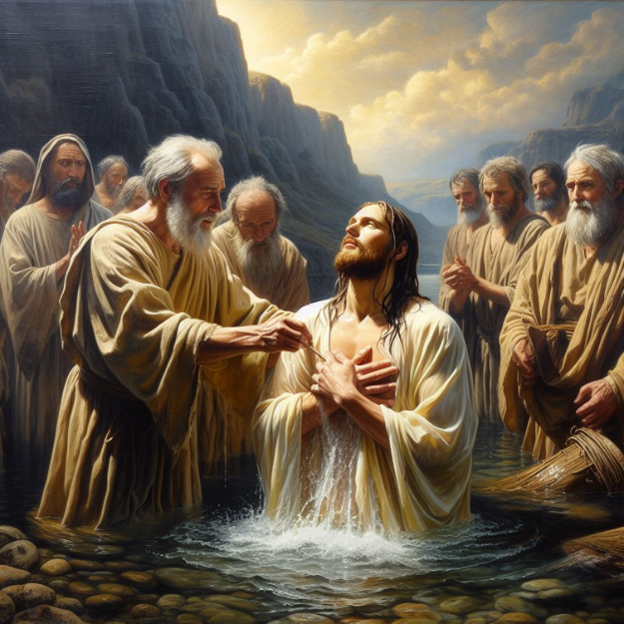
Baptism as the means, not Baptismal Regeneration!
Matthew 28:19 Go, therefore, and make disciples of all the nations, baptizing them in the name of the Father and the Son and the Holy Spirit,
Spiritual transaction takes place…Death for Life. “A passage” Chambers calls it---The Great Divide.
Romans 6:3 Or do you not know that all of us who have been baptized into Christ Jesus have been baptized into His death? 4 Therefore we have been buried with Him through baptism into death, so that, just as Christ was raised from the dead through the glory of the Father, so we too may walk in newness of life.
Colossians 2:9 For in Him all the fullness of Deity dwells in bodily form, 10 and in Him you have been made complete, and He is the head over every ruler and authority; 11 and in Him you were also circumcised with a circumcision performed without hands, in the removal of the body of the flesh by the circumcision of Christ, 12 having been buried with Him in baptism, in which you were also raised with Him through faith in the working of God, who raised Him from the dead. 13 And when you were dead in your wrongdoings and the uncircumcision of your flesh, He made you alive together with Him, having forgiven us all our wrongdoings,
1 Peter 3:18 For Christ also suffered for sins once for all time, the just for the unjust, so that He might bring us to God, having been put to death in the flesh, but made alive in the spirit; 19 in which He also went and made proclamation to the spirits in prison, 20 who once were disobedient when the patience of God kept waiting in the days of Noah, during the construction of the ark, in which a few, that is, eight persons, were brought safely through the water. 21 Corresponding to that, baptism now saves you—not the removal of dirt from the flesh, but an appeal to God for a good conscience—through the resurrection of Jesus Christ,
Method: Immersion…
Matthew 3:6 and they were being baptized by him in the Jordan River, as they confessed their sins.
Motive:
Acts 2:38 Peter said to them, “Repent, and each of you be baptized in the name of Jesus Christ for the forgiveness of your sins; and you will receive the gift of the Holy Spirit.
Two Conditions – Repent, Be Baptized
Two Promises – Redemption, Gift of the Holy Spirit

Communion (the Lord’s Supper)
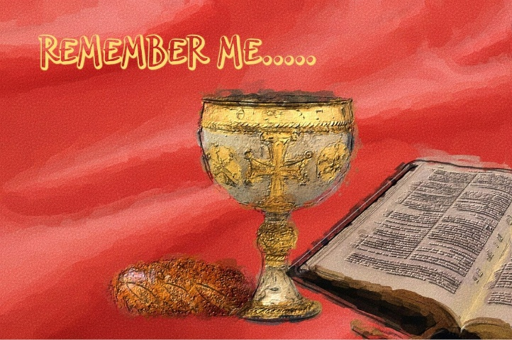
Mark 14:22 While they were eating, He took some bread, and after a blessing He broke it, and gave it to them, and said, “Take it; this is My body.” 23 And when He had taken a cup and given thanks, He gave it to them, and they all drank from it. 24 And He said to them, “This is My blood of the covenant, which is being poured out for many.
1 Corinthians 11: 23 For I received from the Lord that which I also delivered to you, that the Lord Jesus, on the night when He was betrayed, took bread; 24 and when He had given thanks, He broke it and said, “This is My body, which is for you; do this in remembrance of Me.” 25 In the same way He also took the cup after supper, saying, “This cup is the new covenant in My blood; do this, as often as you drink it, in remembrance of Me.” 26 For as often as you eat this bread and drink the cup, you proclaim the Lord’s death until He comes. 27 Therefore whoever eats the bread or drinks the cup of the Lord in an unworthy way, shall be guilty of the body and the blood of the Lord. 28 But a person must examine himself, and in so doing he is to eat of the bread and drink of the cup. 29 For the one who eats and drinks, eats and drinks judgment to himself if he does not properly recognize the body. 30 For this reason many among you are weak and sick, and a number are asleep. 31 But if we judged ourselves rightly, we would not be judged. 32 But when we are judged, we are disciplined by the Lord so that we will not be condemned along with the world. 33 So then, my brothers and sisters, when you come together to eat, wait for one another. 34 If anyone is hungry, have him eat at home, so that you do not come together for judgment. As to the remaining matters, I will give instructions when I come.
What circumstances do you think would cause illness or even death described above?
_______________________________________________________________________________________
_______________________________________________________________________________________

[Read Lesson 7 Prayer before the next group study]

Lesson 7 Prayer

Jeremiah 33:3 ‘Call to Me and I will answer you, and I will tell you great and mighty things, which you do not know.’

Most Christians think of God as being distant and mostly uninvolved with our daily lives. We pray, beg, and plead for Him to hear us and “Move” on our behalf, but rarely see results.
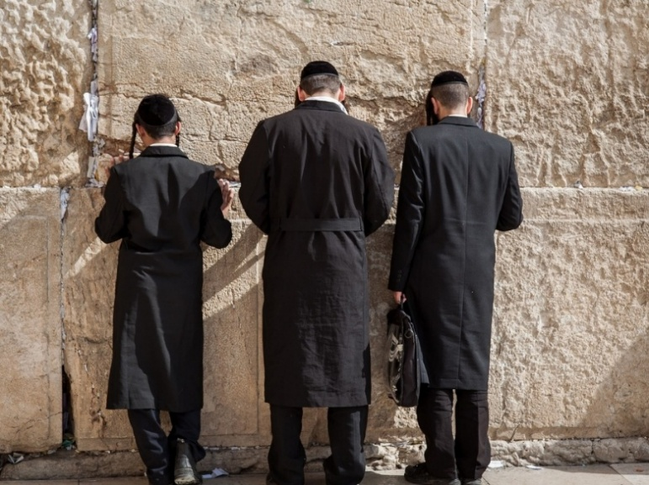
We feel like we might as well be praying to a wall.
But, where is God really, and what is His relationship with us today?
The Lord’s Prayer:
Luke 11:1 It happened that while Jesus was praying in a certain place, when He had finished, one of His disciples said to Him, “Lord, teach us to pray, just as John also taught his disciples.” ² And He said to them, “When you pray, say:
‘Father, hallowed be Your name.
Your kingdom come.
³ Give us each day our daily bread.
⁴ And forgive us our sins,
For we ourselves also forgive everyone who is indebted to us.
And do not lead us into temptation.’”
When Jesus gave this example, it was still the Old Testament. He had not died on the cross yet to redeem us.
After Christ’s resurrection, we are under the New Covenant. In the New Testament we are given new teachings about prayer and our new relationship to God the Father, Jesus Christ, and the Holy Spirit:
John 15:7 If you remain in Me, and My words remain in you, ask whatever you wish, and it will be done for you.
Matthew 19:26 And looking at them, Jesus said to them, “With people this is impossible, but with God all things are possible.”
Mark 9:23 But Jesus said to him, “‘If You can?’ All things are possible for the one who believes.”
Philippians 4:6 Do not be anxious about anything, but in everything by prayer and pleading with thanksgiving let your requests be made known to God.
James 5:16 Therefore, confess your sins to one another, and pray for one another so that you may be healed. A prayer of a righteous person, when it is brought about, can accomplish much.
Ephesians 6:18 With every prayer and request, pray at all times in the Spirit, and with this in view, be alert with all perseverance and every request for all the saints,
Mark 11:24 Therefore, I say to you, all things for which you pray and ask, believe that you have received them, and they will be granted to you.
James 4:2 You lust and do not have, so you commit murder. And you are envious and cannot obtain, so you fight and quarrel. You do not have because you do not ask. ³ You ask and do not receive, because you ask with the wrong motives, so that you may spend what you request on your pleasures.
1 John 3:22 and whatever we ask we receive from Him, because we keep His commandments and do the things that are pleasing in His sight.
James 1:5 But if any of you lacks wisdom, let him ask of God, who gives to all generously and without reproach, and it will be given to him. 6 But he must ask in faith without any doubting, for the one who doubts is like the surf of the sea, driven and tossed by the wind. 7 For that man ought not to expect that he will receive anything from the Lord, 8 being a double-minded man, unstable in all his ways.
Matthew 7:7 “Ask, and it will be given to you; seek, and you will find; knock, and it will be opened to you.
Romans 8:26 Now in the same way the Spirit also helps our weakness; for we do not know what to pray for as we should, but the Spirit Himself intercedes for us with groanings too deep for words; ²⁷ and He who searches the hearts knows what the mind of the Spirit is, because He intercedes for the saints according to the will of God.
1 John 5:14 This is the confidence which we have before Him, that, if we ask anything according to His will, He hears us.
John 14:13 And whatever you ask in My name, this I will do, so that the Father may be glorified in the Son. 14 If you ask Me anything in My name, I will do it. 15 “If you love Me, you will keep My commandments.
Hebrews 11:6 And without faith it is impossible to please Him, for the one who comes to God must believe that He exists, and that He proves to be One who rewards those who seek Him.
John 15:16 You did not choose Me but I chose you, and appointed you that you would go and bear fruit, and that your fruit would remain, so that whatever you ask of the Father in My name He may give to you.
Matthew 7:11 "If you then, being evil, know how to give good gifts to your children, how much more will your Father who is in heaven give what is good to those who ask Him!

Hearing from God
This is important! The primary way to “hear” from God is given in this verse:
Romans 10:17 So faith comes from hearing, and hearing by the word of Christ.
We must study His Word if we expect to ever understand what God desires for us. Probably the most common things God would say to us would be “Have you read my book?” or “You claim you believe the whole Bible but why don’t you believe God still heals?”
John 14:12 Truly, truly I say to you, the one who believes in Me, the works that I do, he will do also; and greater works than these he will do; because I am going to the Father.
Mark 1:40-42 And a man with leprosy came to Jesus, imploring Him and kneeling down, and saying to Him, “If You are willing, You can make me clean.” Moved with compassion, Jesus reached out with His hand and touched him, and said to him, “I am willing; be cleansed.

Sovereignty
God’s Sovereignty
Sovereignty is mentioned here because some believe everything happens by God’s will.
Psalm 103:19 The Lord has established His throne in the heavens, And His sovereignty rules over all.
Isaiah 14:24 The Lord of armies has sworn, saying, “Certainly, just as I have intended, so it has happened, and just as I have planned, so it will stand,

God’s Will does not always come to pass
2 Peter 3:9 The Lord is not slow about His promise, as some count slowness, but is patient toward you, not willing for any to perish, but for all to come to repentance.
So God’s will is for no one to perish, yet most do perish on the “wide road to destruction”without being saved. Also, many perished in the desert during the Exodus.
Galatians 1:3 Grace to you and peace from God the Father and our Lord Jesus Christ, ⁴ who gave Himself for our sins so that He might rescue us from this present evil age, according to the will of our God and Father,
Jeremiah 29:11 For I know the plans that I have for you,’ declares the Lord, ‘plans for prosperity and not for disaster, to give you a future and a hope.
1 Timothy 2:3 This is good and acceptable in the sight of God our Savior, ⁴ who wants all people to be saved and to come to the knowledge of the truth.
1 Thessalonians 5:18 in everything give thanks; for this is the will of God for you in Christ Jesus.
John 6:40 For this is the will of My Father, that everyone who sees the Son and believes in Him will have eternal life, and I Myself will raise him up on the last day.”

Man’s Dominion, Free Will – we choose to follow God or not
Genesis 1:26 Then God said, “Let Us make mankind in Our image, according to Our likeness; and let them rule over the fish of the sea and over the birds of the sky and over the livestock and over all the earth, and over every crawling thing that crawls on the earth.”
Psalm 8:4-8 What is man that You think of him, And a son of man that You are concerned about him? 5 Yet You have made him a little lower than God, And You crown him with glory and majesty! 6 You have him rule over the works of Your hands; You have put everything under his feet, 7 All sheep and oxen, And also the animals of the field, 8 The birds of the sky, and the fish of the sea, Whatever passes through the paths of the seas.
Many verses show mankind does indeed have FREE WILL:
Genesis 3:6 When the woman saw that the tree was good for food, and that it was a delight to the eyes, and that the tree was desirable to make one wise, she took some of its fruit and ate; and she also gave some to her husband with her, and he ate.
John 3:16 “For God so loved the world, that He gave His only Son, so that everyone who believes in Him will not perish, but have eternal life.

[Read Lesson 8 The Church before the next group study]

Lesson 8 The Church

Ephesians 1:22 And He put all things in subjection under His feet, and gave Him as head over all things to the church, 23 which is His body, the fullness of Him who fills all in all.
Colossians 1:17 He is before all things, and in Him all things hold together. 18 He is also head of the body, the church; and He is the beginning, the firstborn from the dead, so that He Himself will come to have first place in everything.
Acts 20:28 Be on guard for yourselves and for all the flock, among which the Holy Spirit has made you overseers, to shepherd the church of God which He purchased with His own blood.
Ephesians 4:11 And He gave some as apostles, and some as prophets, and some as evangelists, and some as pastors and teachers, 12 for the equipping of the saints for the work of service, to the building up of the body of Christ
1 Timothy 3:15 but in case I am delayed, I write so that you will know how one should act in the household of God, which is the church of the living God, the pillar and support of the truth.
1 Corinthians 12:27 Now you are Christ’s body, and individually parts of it.
1 Peter 2:9-10 But you are a chosen people, a royal priesthood, a holy nation, a people for God’s own possession, so that you may proclaim the excellencies of Him who has called you out of darkness into His marvelous light; ¹⁰ for you once were not a people, but now you are the people of God; you had not received mercy, but now you have received mercy.

In your own words, what is “The Church”? What should the church be doing today?
__________________________________________________________________________________
__________________________________________________________________________________
__________________________________________________________________________________

The Importance of Unity
1 Corinthians 1:10 Now I exhort you, brethren, by the name of our Lord Jesus Christ, that you all agree and that there be no divisions among you, but that you be made complete in the same mind and in the same judgment. 11 For I have been informed concerning you, my brethren, by Chloe's people, that there are quarrels among you. 12 Now I mean this, that each one of you is saying, "I am of Paul," and "I of Apollos," and "I of Cephas," and "I of Christ." 13 Has Christ been divided? Paul was not crucified for you, was he? Or were you baptized in the name of Paul?
Romans 16:17 Now I urge you, brethren, keep your eye on those who cause dissensions and hindrances contrary to the teaching which you learned, and turn away from them. 18 For such men are slaves, not of our Lord Christ but of their own appetites; and by their smooth and flattering speech they deceive the hearts of the unsuspecting.
The global church should be of one mind with only minor differences of opinion that don’t merit breaking out into divisive denominations. We should all be an example of unity like this:



Instead today’s Christians are divided and scattered just as Satan planned:

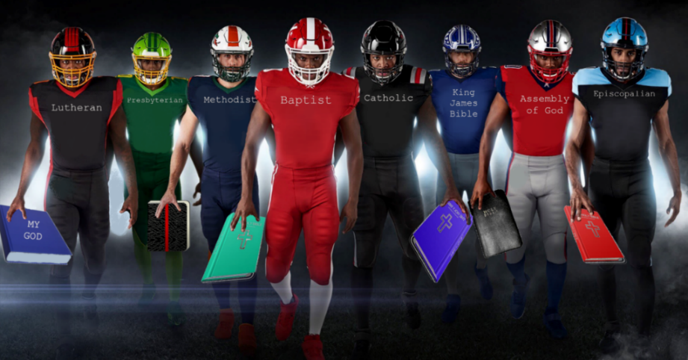

[Read Lesson 9 End Times before the next group study]

Lesson 9 End Times

Daniel 12:1 “.... And there will be a time of distress such as never occurred since there was a nation until that time; and at that time your people, everyone who is found written in the book, will be rescued. 2 And many of those who sleep in the dust of the ground will awake, these to everlasting life, but the others to disgrace and everlasting contempt. 3 And those who have insight will shine like the glow of the expanse of heaven, and those who lead the many to righteousness, like the stars forever and ever.
Luke 23:42 And he was saying, “Jesus, remember me when You come into Your kingdom!” 43 And He said to him, “Truly I say to you, today you will be with Me in Paradise.”
Matthew 24:3 And as He was sitting on the Mount of Olives, the disciples came to Him privately, saying, “Tell us, when will these things happen, and what will be the sign of Your coming, and of the end of the age?” 4 And Jesus answered and said to them, “See to it that no one misleads you. 5 For many will come in My name, saying, ‘I am the Christ,’ and they will mislead many people. 6 And you will be hearing of wars and rumors of wars. See that you are not alarmed, for those things must take place, but that is not yet the end. 7 For nation will rise against nation, and kingdom against kingdom, and there will be famines and earthquakes in various places. 8 But all these things are merely the beginning of birth pains.
Luke 17:26 And just as it happened in the days of Noah, so will it also be in the days of the Son of Man: ²⁷ people were eating, they were drinking, they were marrying, and they were being given in marriage, until the day that Noah entered the ark, and the flood came and destroyed them all.
2 Timothy 3:1 But realize this, that in the last days difficult times will come. 2 For people will be lovers of self, lovers of money, boastful, arrogant, slanderers, disobedient to parents, ungrateful, unholy, 3 unloving, irreconcilable, malicious gossips, without self-control, brutal, haters of good, 4 treacherous, reckless, conceited, lovers of pleasure rather than lovers of God, 5 holding to a form of godliness although they have denied its power; avoid such people as these.
Acts 1:9 And after He had said these things, He was lifted up while they were watching, and a cloud took Him up, out of their sight. 10 And as they were gazing intently into the sky while He was going, then behold, two men in white clothing stood beside them, 11 and they said, “Men of Galilee, why do you stand looking into the sky? This Jesus, who has been taken up from you into heaven, will come in the same way as you have watched Him go into heaven.”
John 14:1 “Do not let your heart be troubled; believe in God, believe also in Me. 2 In My Father’s house are many rooms; if that were not so, I would have told you, because I am going there to prepare a place for you. 3 And if I go and prepare a place for you, I am coming again and will take you to Myself, so that where I am, there you also will be.
1 Thessalonians 4:16 For the Lord Himself will descend from heaven with a shout, with the voice of the archangel and with the trumpet of God, and the dead in Christ will rise first. 17 Then we who are alive, who remain, will be caught up together with them in the clouds to meet the Lord in the air, and so we will always be with the Lord.
Matthew 25:41 “Then He will also say to those on His left, ‘Depart from Me, you accursed people, into the eternal fire which has been prepared for the devil and his angels; 42 for I was hungry, and you gave Me nothing to eat; I was thirsty, and you gave Me nothing to drink; 43 I was a stranger, and you did not invite Me in; naked, and you did not clothe Me; sick, and in prison, and you did not visit Me.’ 44 Then they themselves also will answer, ‘Lord, when did we see You hungry, or thirsty, or as a stranger, or naked, or sick, or in prison, and did not take care of You?’ 45 Then He will answer them, ‘Truly I say to you, to the extent that you did not do it for one of the least of these, you did not do it for Me, either.’
2 Peter 3:3 Know this first of all, that in the last days mockers will come with their mocking, following after their own lusts, 4 and saying, “Where is the promise of His coming? For ever since the fathers fell asleep, all things continue just as they were from the beginning of creation.” 5 For when they maintain this, it escapes their notice that by the word of God the heavens existed long ago and the earth was formed out of water and by water, 6 through which the world at that time was destroyed by being flooded with water.
1 Timothy 4:1 But the Spirit explicitly says that in later times some will fall away from the faith, paying attention to deceitful spirits and teachings of demons,
2 Peter 3:11 Since all these things are to be destroyed in this way, what sort of people ought you to be in holy conduct and godliness, 12 looking for and hastening the coming of the day of God, because of which the heavens will be destroyed by burning, and the elements will melt with intense heat! 13 But according to His promise we are looking for new heavens and a new earth, in which righteousness dwells.
John 5:25 Truly, truly, I say to you, a time is coming and even now has arrived, when the dead will hear the voice of the Son of God, and those who hear will live. 26 For just as the Father has life in Himself, so He gave to the Son also to have life in Himself; 27 and He gave Him authority to execute judgment, because He is the Son of Man. 28 Do not be amazed at this; for a time is coming when all who are in the tombs will hear His voice, 29 and will come out: those who did the good deeds to a resurrection of life, those who committed the bad deeds to a resurrection of judgment.
1 Corinthians 15:51Behold, I am telling you a mystery; we will not all sleep, but we will all be changed, 52 in a moment, in the twinkling of an eye, at the last trumpet; for the trumpet will sound, and the dead will be raised imperishable, and we will be changed.
Revelation 13:16 And he causes all, the small and the great, the rich and the poor, and the free and the slaves, to be given a mark on their right hands or on their foreheads, 17 and he decrees that no one will be able to buy or to sell, except the one who has the mark, either the name of the beast or the number of his name.
Revelation 20:1Then I saw an angel coming down from heaven, holding the key of the abyss and a great chain in his hand. 2 And he took hold of the dragon, the serpent of old, who is the devil and Satan, and bound him for a thousand years; 3 and he threw him into the abyss and shut it and sealed it over him, so that he would not deceive the nations any longer, until the thousand years were completed; after these things he must be released for a short time. 4 Then I saw thrones, and they sat on them, and judgment was given to them. And I saw the souls of those who had been beheaded because of their testimony of Jesus and because of the word of God, and those who had not worshiped the beast or his image, and had not received the mark on their foreheads and on their hands; and they came to life and reigned with Christ for a thousand years. 5 The rest of the dead did not come to life until the thousand years were completed. This is the first resurrection. 6 Blessed and holy is the one who has a part in the first resurrection; over these the second death has no power, but they will be priests of God and of Christ, and will reign with Him for a thousand years.
Revelation 20:11Then I saw a great white throne and Him who sat upon it, from whose presence earth and heaven fled, and no place was found for them. 12 And I saw the dead, the great and the small, standing before the throne, and books were opened; and another book was opened, which is the book of life; and the dead were judged from the things which were written in the books, according to their deeds. 13 And the sea gave up the dead who were in it, and Death and Hades gave up the dead who were in them; and they were judged, each one of them according to their deeds. 14 Then Death and Hades were thrown into the lake of fire. This is the second death, the lake of fire. 15 And if anyone’s name was not found written in the book of life, he was thrown into the lake of fire.
1 Thessalonians 5:3 While they are saying, “Peace and safety!” then sudden destruction will come upon them like labor pains upon a pregnant woman, and they will not escape.
Luke 21:25 “There will be signs in the sun and moon and stars, and on the earth distress among nations, in perplexity at the roaring of the sea and the waves, 26 people fainting from fear and the expectation of the things that are coming upon the world; for the powers of the heavens will be shaken. 27 And then they will see the Son of Man coming in a cloud with power and great glory. 28 But when these things begin to take place, straighten up and lift up your heads, because your redemption is drawing near.” 29 And He told them a parable: “Look at the fig tree and all the trees: 30 as soon as they put forth leaves, you see for yourselves and know that summer is now near. 31 So you too, when you see these things happening, recognize that the kingdom of God is near. 32 Truly I say to you, this generation will not pass away until all things take place.
Matthew 24:14 This gospel of the kingdom shall be preached in the whole world as a testimony to all the nations, and then the end will come.
Matthew 24:44 For this reason you must be ready as well; for the Son of Man is coming at an hour when you do not think He will.
Whether the “End Times” is soon or not, our own personal end is when we take our last breath. Therefore, we should ALWAYS BE READY to meet Jesus!

[The last session closes with a Summary and “The Great Commission”.]

Summary
We must be secure in these FACTS:
- There is a Creator God – Evolution is a LIE
- The Bible is God’s TRUE Word and revelation to us
- All human kind has rebelled against God and condemned ourselves to Hell
- There was a GLOBAL FLOOD and there is GLOBAL EVIDENCE of this fact
- Jesus Christ died for our sins and reconciled us to God the Father
- Jesus is the ONLY WAY to Heaven
Most people identifying as “Christian” DO NOT BELIEVE ALL OF THE ABOVE!
If you weren’t saved before starting this series, you should be by now. If not, review all the scriptures mentioned in this program and do all necessary research until you get yourself saved!

The Great Commission
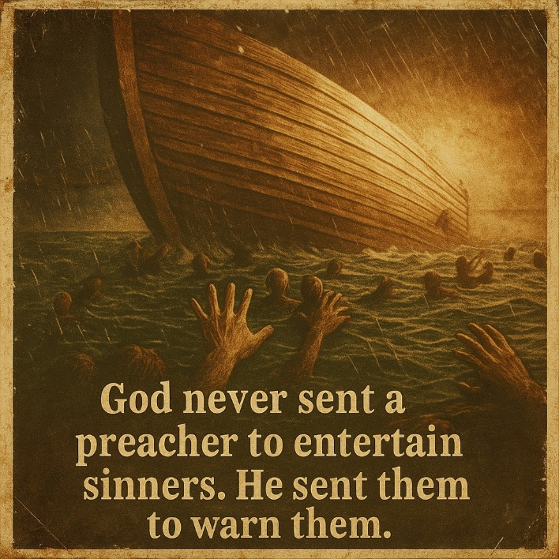
Acts 1:8 but you will receive power when the Holy Spirit has come upon you; and you shall be My witnesses both in Jerusalem and in all Judea, and Samaria, and as far as the remotest part of the earth.”
Matthew 28:18 And Jesus came up and spoke to them, saying, "All authority has been given to Me in heaven and on earth.19 "Go therefore and make disciples of all the nations, baptizing them in the name of the Father and the Son and the Holy Spirit, 20 teaching them to observe all that I commanded you; and lo, I am with you always, even to the end of the age."

Mark 16:15 And He said to them, "Go into all the world and preach the gospel to all creation. 16 "He who has believed and has been baptized shall be saved; but he who has disbelieved shall be condemned. 17 "These signs will accompany those who have believed: in My name they will cast out demons, they will speak with new tongues; 18 they will pick up serpents, and if they drink any deadly poison, it will not hurt them; they will lay hands on the sick, and they will recover."

Romans 10:13 for "WHOEVER WILL CALL ON THE NAME OF THE LORD WILL BE SAVED." 14 How then will they call on Him in whom they have not believed? How will they believe in Him whom they have not heard? And how will they hear without a preacher? 15 How will they preach unless * they are sent? Just as it is written, "HOW BEAUTIFUL ARE THE FEET OF THOSE WHO BRING GOOD NEWS OF GOOD THINGS!" 16 However, they did not all heed the good news; for Isaiah says, "LORD, WHO HAS BELIEVED OUR REPORT?" 17 So faith comes from hearing, and hearing by the word of Christ.
2 Corinthians 5 Therefore if anyone is in Christ, he is a new creature; the old things passed away; behold, new things have come. 18 Now all these things are from God, who reconciled us to Himself through Christ and gave us the ministry of reconciliation, 19 namely, that God was in Christ reconciling the world to Himself, not counting their trespasses against them, and He has committed to us the word of reconciliation. 20 Therefore, we are ambassadors for Christ, as though God were making an appeal through us; we beg you on behalf of Christ, be reconciled to God.
John 15:8 My Father is glorified by this, that you bear much fruit, and so prove to be My disciples.
James 1:22 But prove yourselves doers of the word, and not just hearers who deceive themselves.
Ephesians 4:11 And He gave some as apostles, some as prophets, some as evangelists, some as pastors and teachers, ¹² for the equipping of the saints for the work of ministry, for the building up of the body of Christ;
1 Peter 3:15 but sanctify Christ as Lord in your hearts, always being ready to make a defense to everyone who asks you to give an account for the hope that is in you, but with gentleness and respect;
2 Timothy 4:2 preach the word; be ready in season and out of season; correct, rebuke, and exhort, with great patience and instruction.
You don’t need to go to a “Mission Field”. There are lost people all around and you are never done.
This is not the END of your Discipleship, it is just the BEGINNING! We must continue to grow all our lives.
And don’t worry about being “worthy” – you’re not, and neither is anybody else!

Resources
[If you go to Resources on the Discipleship From the Beginning website (biblegodsword.com), you can just click on the following links. You can also download copies of this Discipleship guide as a PDF for printing and reading, or as a MS WORD document to modify and make it your own for yourself or Church. FREE to use because it is mostly Scrpture.]
Resources for further Creation/Evolution investigation:
Do your own web searches for "Creation Evolution debate", "Bible or Creation proof", etc.
Institute for Creation Research https://www.icr.org/
Ark Encounter https://arkencounter.com/
creationevidence.org
nwcreation.net
https://www.talkorigins.org/faqs/flood-myths.html
https://nwcreation.net/noahlegends.html
biblegodsword.com Videos link below https://www.youtube.com/channel/UC3neFL87htqNTUQNo-f_uAQ
DVD videos:
• Expelled No Intelligence Allowed
• Genesis: Paradise Lost
• Is Genesis History?
• Patterns of Evidence – Exodus
• The Exodus Decoded
https://www.onlinechristiancourses.com/
Frank Turek – “Not enough faith to be an atheist” https://crossexamined.org/
DVD videos from my list:
• Expelled No Intelligence Allowed
• Genesis: Paradise Lost
• Is Genesis History?
• Patterns of Evidence – Exodus
• The Case for Christ (Book also)
• The Exodus Decoded

Study in Healing:
Healing Journeys including 8 vol DVDs Andrew Wommack
awmi.net

Healing in Old Testament
Psalm 103:1-3 Bless the Lord, my soul, And all that is within me, bless His holy name.
2 Bless the Lord, my soul, And do not forget any of His benefits;
3 Who pardons all your guilt, Who heals all your diseases;
Verses that show healing is still possible today:

1 Peter 2:24 and He Himself brought our sins in His body up on the cross, so that we might die to sin and live for righteousness; by His wounds you were healed.

Matthew 14:14 When He came ashore, He saw a large crowd, and felt compassion for them and healed their sick.

He also gives us authority and power:
1 John 5:14 This is the confidence which we have before Him, that, if we ask anything according to His will, He hears us. 15 And if we know that He hears us in whatever we ask, we know that we have the requests which we have asked from Him.

John 14:12 Truly, truly I say to you, the one who believes in Me, the works that I do, he will do also; and greater works than these he will do; because I am going to the Father.

Luke 10:19 Behold, I have given you authority to walk on snakes and scorpions, and authority over all the power of the enemy, and nothing will injure you.

2 Timothy 1:6 For this reason I remind you to kindle afresh the gift of God which is in you through the laying on of my hands. 7 For God has not given us a spirit of timidity, but of power and love and discipline.

1 Corinthians 4:20 For the kingdom of God is not in words, but in power.

Matthew 19:26 And looking at them, Jesus said to them, “With people this is impossible, but with God all things are possible.”

Healing Resources at awmi.net

